**Adagio – Order Entry (Invoicing for Sale of Product from Americold)**

* Open Order Entry Module
* ORDERS tab – Click NEW  
  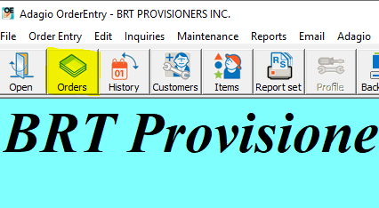
* Enter **CUSTOMER #**
* If customer information is correct then click **OK**
* Order Date = date of sale from P&L sheet
* Ship Via = PICK UP (have to write this in)
* Location = AME or AMG (which cold storage location)
* Date = date of sale (day product is on truck/delivery date)
* Comments = Lot #(s) order taken from (see spreadsheet titled “Cold Storage Inventory” saved in G:\Provisioners\BAIT folder
* Reference = PO# (if applicable)
* Tax Group – if applicable, enter appropriate from dropdown

**DETAILS TAB (**double click the Blue Line)

* Enter Item Number for product (same as used to enter the inventory)
* Ordered = quantity ordered by customer, -- TAB x 2
* Unit Price = enter sales price based on UOM (kgs, lbs, each)
* Shipped = amount shipped (kg, lbs, each)
* Tax Status – change to Taxable if necessary
* Double check quantity shipped, price/unit and extension total
* Click OK
* Close screen

**NOTE – for COD fish, double click blue line again to enter Freight  
 Fuel SUR DS  
 1.0 Ordered LBS  
 1.00 Shipped LBS

**TOTALS TAB**

* Actual Ship Date & Invoice Date should be the same as the Date of Sale (used in Header section from P&L)
* Click OK to accept INVOICE # (write down invoice # on P&L sheet beside Sales Invoice)
* Specifications – choose Invoice B/W CND or Invoice B/W USA
* Clink PRINT / Click YES
* Email/Fax invoice to the customer

**NOTE – 2 copies will print, one copy goes on top of current year file cabinet (2 hole clip board), the other copy stays with the order package

* Add Invoice #, Customer & Delivery Date to the spreadsheet titled “Cold Storage Inventory” saved in G:\Provisioners\BAIT folder